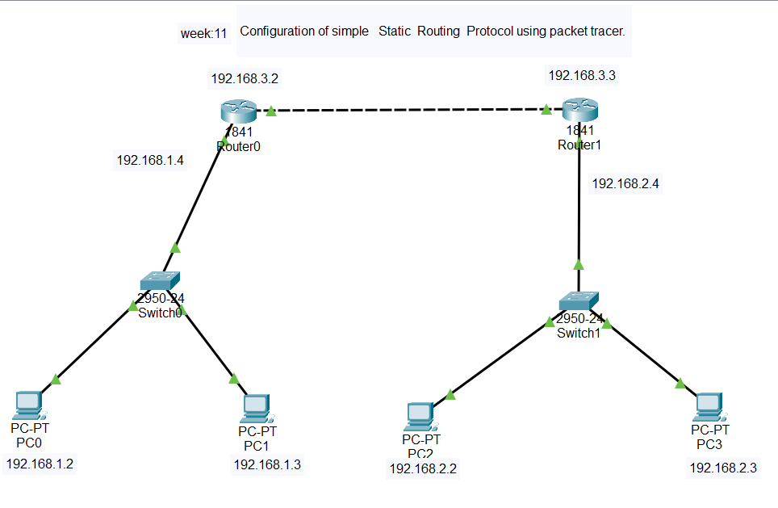

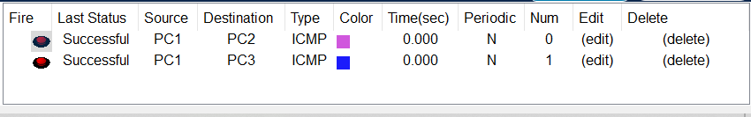

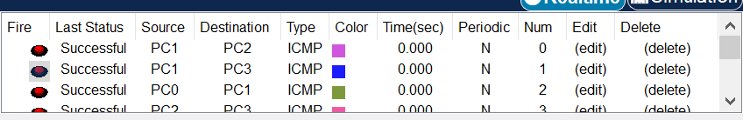
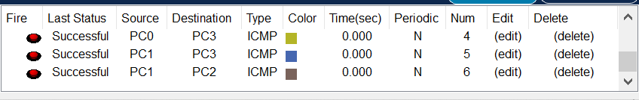

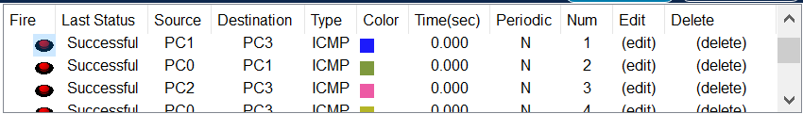

Configuration of PC0:-
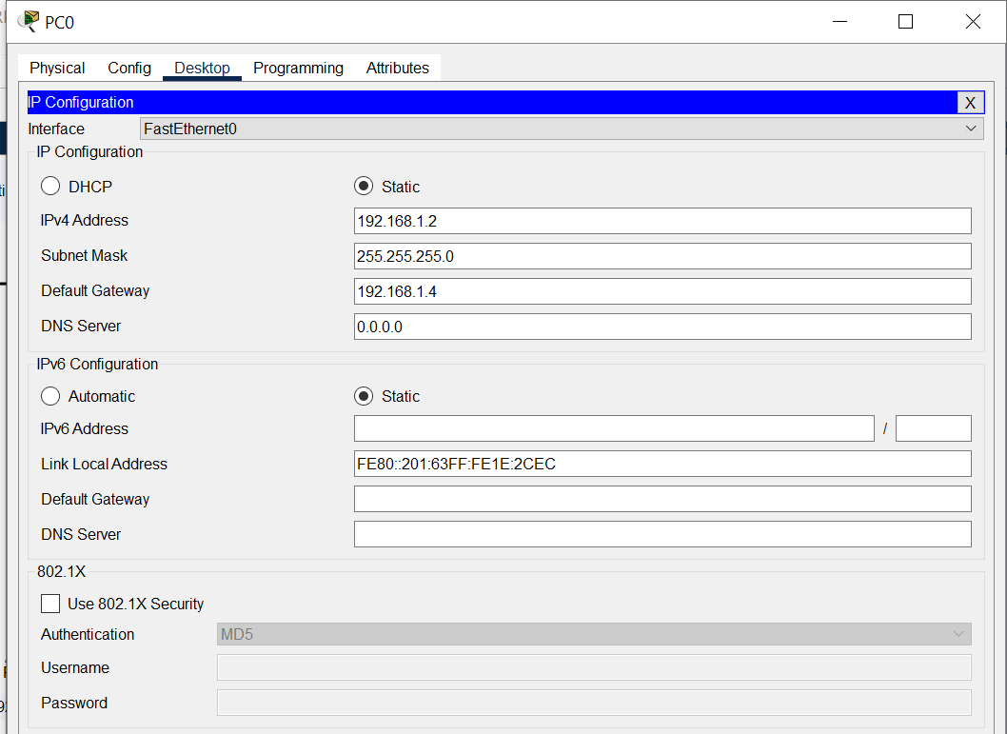
Configuration of PC1:-
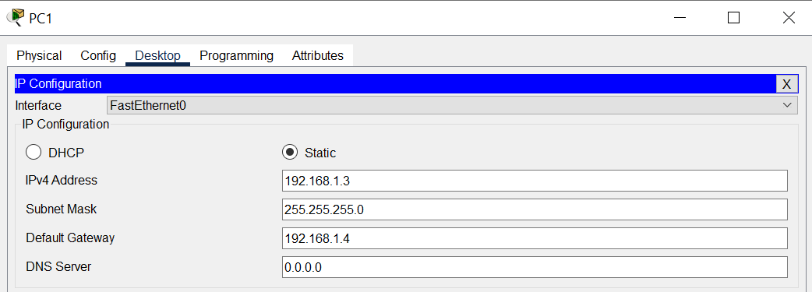

Configuration of PC2:-
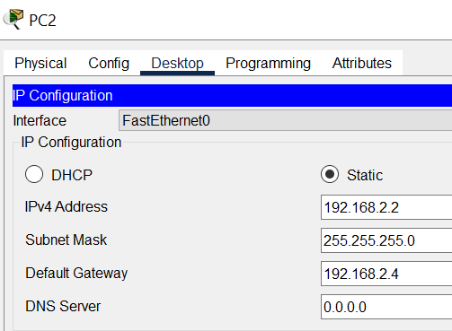

Configuration of PC3
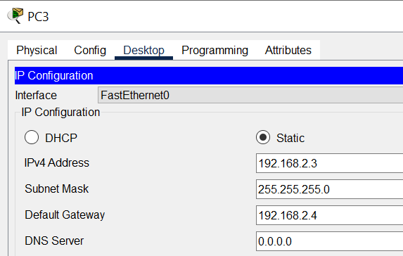

Configuration of Router1:-
FastEthernet 0/0
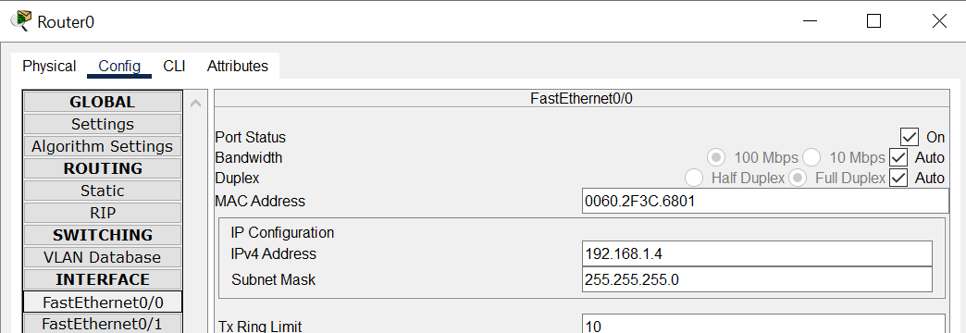

Fast Ethernet 0/1

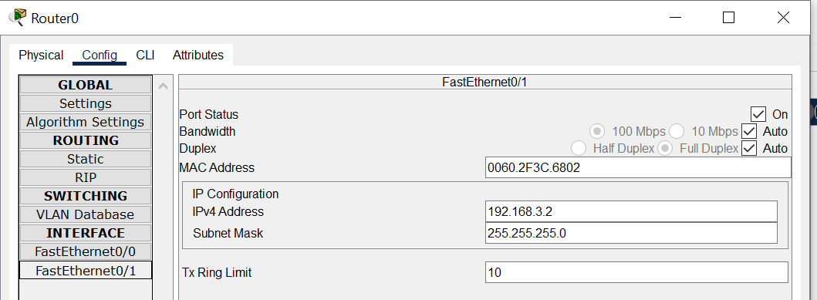
In Router0 :
Go to config-→ static
Enter network address , mask and nexthop fields and then click on Add button
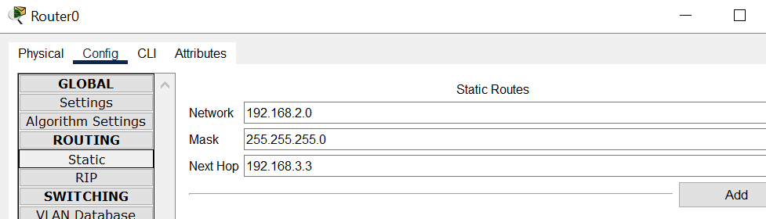

Configuration of Router1:-
Configuration of FastEthernet0/0
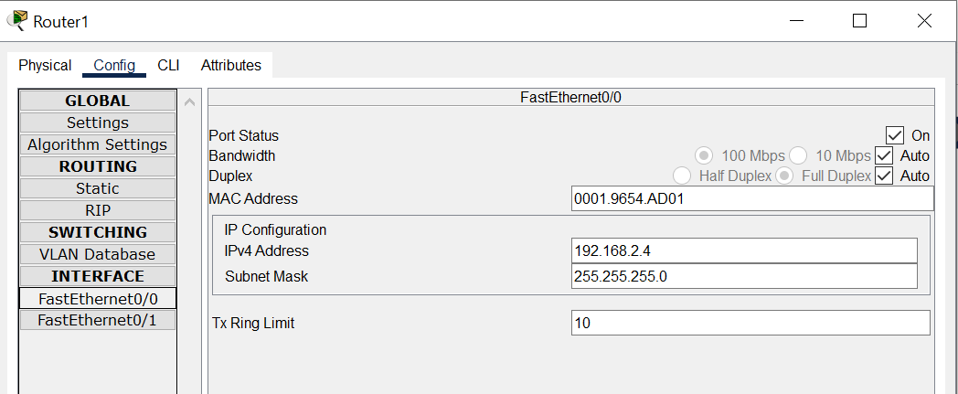

Configuration of FastEthernet 0/1
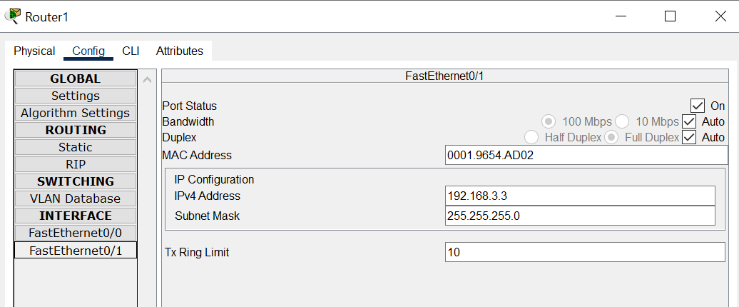

In Router1 :
Go to config-→ static
Enter network , mask and nexthop fields and then click on Add button

